EXPERIMENT 6

**Aim**:To study powerfactor improvement by the addition of a capacitor bank across the load in the matlab Simulink model

**Question**:A 3-phase,50 hz,400v motor develops 100 hp(74.6kw), the powerfactor being 0.75 lagging and efficiency 93%.A bank of capacitor is connected in delta across the supply teminals and the powerfactor is raised to 0.95 lagging. Each of the capacitorunits is built of 4 similar 100v capacitors.Develope the Simulink model for same also determine the capacitance of each phase.

**MATLAB code:**

clc

clear all

v=input('enter the v rms value:');

P2=input('enter the output power:');

e=input('enter the efficiency:');

f=input('enter the frequency:');

P1=(P2*100)/e

pf1=input('enter 1st pf:');

pf2=input('enter 2nd pf:');

a=acos(pf1);

b=acos(pf2);

qc=P1*(tan(a)-tan(b))

q=qc/3

c=q/(v^2*2*pi*f)

**Calculation**

Pin=P2/e

Pi1=cos(0.75)

Pi2=cos(0.95)

Qc=pin(tanpi1-tanpi2)

Qcphase=qc/3

C=Qcphase/2*pi*f*v^2

**OUTPUT:**

enter the v rms value:400

enter the output power:74600

enter the efficiency:93

enter the frequency:50

P1 =8.0215e+04

enter 1st pf:0.75

enter 2nd pf:0.95

qc =4.4378e+04

q =1.4793e+04

c =2.9429e-04

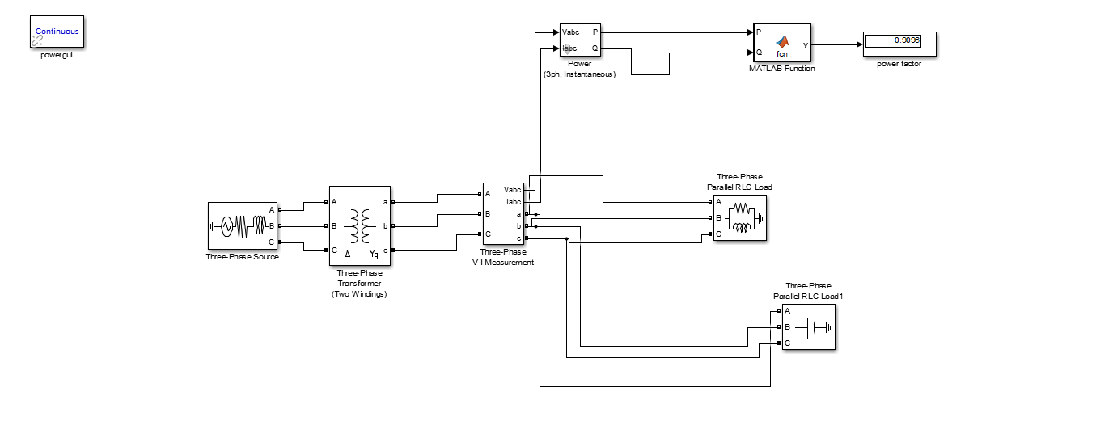**SIMULINK MODEL**